***Jorge Chable***

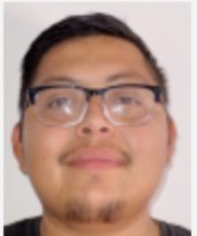

Address: Antioch, CA 94509

Phone: (415)574-8413

E-mail: [chablejorge569@gmail.com](mailto:chablejorge569@gmail.com)

Languages: English & Spanish.

Dynamic remodeler, carpenter, constructor with 9 years of extensive experience in different trades of Construction, recognized for exceptional craftsmanship in carpentry and tiling. Adept at delivering innovative solutions while ensuring safety and quality. Proven problem-solver and team player, skilled in drywall installation and committed to enhancing client satisfaction through meticulous attention to detail. Bilingual,

I’m authorized to work legally in the United States. Clean Dmv record. I have my own truck, I have my own tools for different types of construction branches. Smoke-free, Drugs free. I am available to work Monday to Friday, with flexibility to work overtime.

***References:***

James Jordan

He was my manager at Home Pride Inc. in 2018-2019. We've known each other for 7 years.

Phone number: (650) 420-8815.

Abdul Ahad

My boss at Black Bear Dynasty.two years of knowing each other

Phone number: (925)984-3528.

Leo Medina

I have done work for him. occasionally we work together.

We've known each other for two years.

Phone number: (510)606-2794.

***Skills***

• Safety awareness

• Flooring installation

• Plumbing proficiency

• Drywall installation

• Window replacement

• Siding application

• Fixture installation

• Fence installation

• Wallpaper removal

• Cabinet installation

• Construction background

• Framing construction

• Construction experience

• Door installation

• Carpentry expertise

• Masonry work

• Landscaping basics

• Demolition techniques

• Painting techniques

• Tile setting

• Deck building

• Framing

• Demolition

• Tile installation

• Insulation installation

• Staircase construction

• Electrical

• Concrete pouring

• Heavy equipment operation

• Hand tool proficiency

• Electrical wiring

• Problem-solving

• Heavy lifting

• Installation and finishing

• Physical agility and coordination

• Team player

• Joining work

• Measurements and calculations

• Materials salvage

• Job site measuring and layout

• Form construction and removal

• Teamwork and collaboration

• Attention to detail

• Problem-solving abilities

• Multitasking

• Punctual

• Multitasking Abilities

• Power tools operation

• Loading and unloading

• Excellent communication

• Organizational skills

• Team collaboration

• Active listening

• Effective communication

• Hand and power tool operation

• Adaptability and flexibility

• Worksite safety and maintenance

• Decision-making

• Material loading and unloading

• Materials handling

• Structural knowledge

• Relationship building

• Safety procedures

• Site preparation

• Equipment maintenance

• Team building

• Self motivation

• Interpersonal skills

• Analytical thinking

• Professionalism

• Hazardous materials handling

***Work History***

2024-09 - 2025-02

Remodeler and Carpenter Carlisle Construction, Concord, CA

In this company, my work specialized more in carpentry and kitchen remodeling. I worked with kitchen electricity, sheetrock, texture, and painting. I also worked remodeling bathrooms.

Utilized advanced tools and equipment to complete complex remodeling projects with precision and speed.

Maintained safe work environments by adhering to proper safety protocols and conducting regular inspections of job sites.

Delivered top-notch filing work for bathroom remodels that enhanced both appearance and functionality of the space.

Continuously educated myself on industry trends and best practices to provide clients with innovative solutions and stay ahead of the competition.

Provided exceptional craftsmanship in carpentry work for custom cabinetry installations, built-ins, and other interior features.

2023-05 - 2024-08

Carpenter & Landscaper.

Black Bear Dinasty, Hayward, CA

In this company, we works as a carpenter and remodeler, as well as a landscaper. We does demolitions, retaining walls, decks, fence pavers, and anything else involving wood and hardwork.

Collaborated with gardeners to plan and design outdoor spaces. We work concrete too.

Utilized lawn striping methods for healthy grass growing and appearance.

Assisted with irrigation system maintenance and repair.

Installed stonework according to landscape design plan and client specifications.

Constructed hardscape elements like patios, walkways, retaining walls, outdoor kitchens, fire pits, water features for enhanced functionality of outdoor spaces.

Enhanced customer satisfaction by providing high-quality landscaping services and maintaining clear communication throughout the project.

2022-02 -2023-05

Residential Remodeler

Seaview Maintenance, Half Moon Bay

Finished surfaces of woodwork or wallboard in houses and buildings with paneling, paint and hand tools.

Helped with door and window installations.

Installed drywall, siding and other structural components.

Managed safe and efficient use of tools and equipment on construction sites.

Followed instructions and safety protocols while operating machinery and equipment.

2020-04 - 2022-02

Constructor, Carpenter and Remodeler Foreman

CB CONSTRUCTION AND DESING, Discovery Bay, CA

Maintained high safety standards on construction sites, resulting in fewer accidents and injuries.

Completed projects ahead of schedule by optimizing workflows and employing efficient construction methods.

Ensured timely completion of projects by closely monitoring progress and adjusting schedules as needed.

Conducted thorough quality control inspections throughout each phase of construction, identifying potential issues early on and taking corrective action when necessary.

Improved team productivity by fostering a collaborative work environment and providing guidance on best practices.

Brought materials and tools from trucks and storage facilities to work site locations and organized for

expected needs.

Assisted with basic carpentry work such as installing wooden floors and crown molding.

Used a variety of hand and power tools to complete tasks.

Worked on sites, installing roofs and other exterior components.

Installed drywall, siding and other structural components.

In this company we worked with EPOXY too.

Completed installations of building structures, trim, flooring, and cabinetry.

Helped with door and window installations.

Planned and executed work with proper tools and materials to maximize productivity.

And much more.

2017-12 - 2019-11

Home Remodeler, Carpenter, Constructor.

Home Pride Inc, Pacifica, CA

This company involved a lot of teamwork, demolishing, replacing, and installing everything new. It was very high-quality work, complete remodeling in every corner of the house in a short amount of time. I specialized in kitchens and bathrooms, and I learned to work with tiles.

2016-08 - 2017-12

Constructor

Romkon Inc, San Francisco, CA

In this company, we worked as a team, learned demolition techniques, repaired and renovated building foundations in San Francisco, and reinforced structures. We remodeled entire apartments and also built a house in San Carlos, California. We started that house from the foundation to the finish. A very modern house with lush, luxurious details.

2015-12 - 2016-08

Labor, Carpenter

DeAbreu Construction, Antioch, CA

My first job in a company as a builder, where I specialized in many branches of construction. In this company we did home construction projects from start to finish. I learned to do foundations, flooring, framing, insulation, sheeting, roofing, siding, sheetrock, taping, drywall, texture, paint, electrical work, windows, doors, concrete and much more.

2014-11 - 2015-12

Apprentice, Helper, Demoler & Labor.

Jorge Contractor, Richmond, CA

I worked as a contractor's helper. My first job was learning how to demolish, dig, look for pipes, and mark so others wouldn't damage the pipes while digging. He taught me how to make paver, everything Ilearned about landscaping, retaining walls, decks, and fencing. He taught me how to use machines, including using the Bobcat to load trucks with dirt or debris, Then I learned to do jobs more inclined towards carpentry.

2014-07 - 2014-11

Cook

Wise Sons, San Francisco, CA

2013-09 - 2014-11

Dishwasher

Mels Drive Inn, San Francisco, CA

2014-01 - 2014-07

Cook

Lolinda, San Francisco, CA

I want to add some photos about some works. 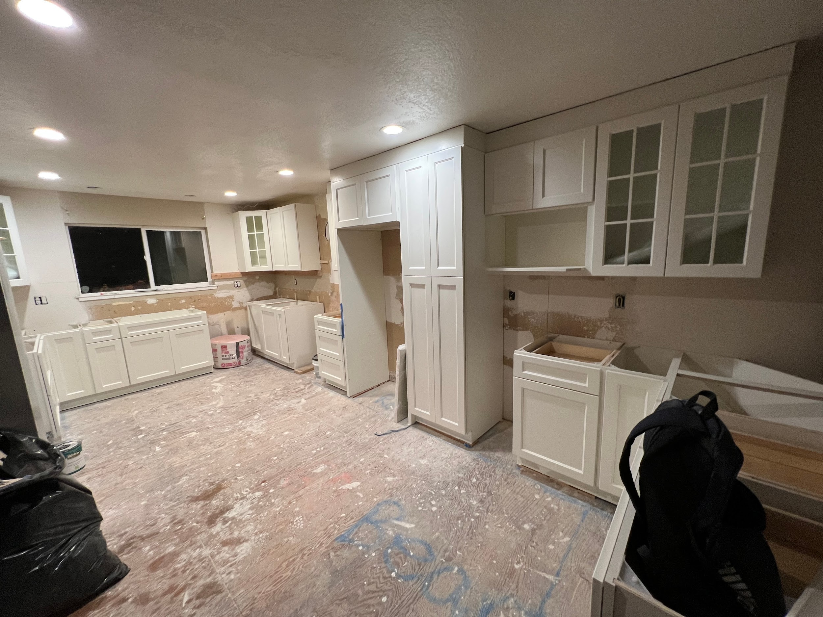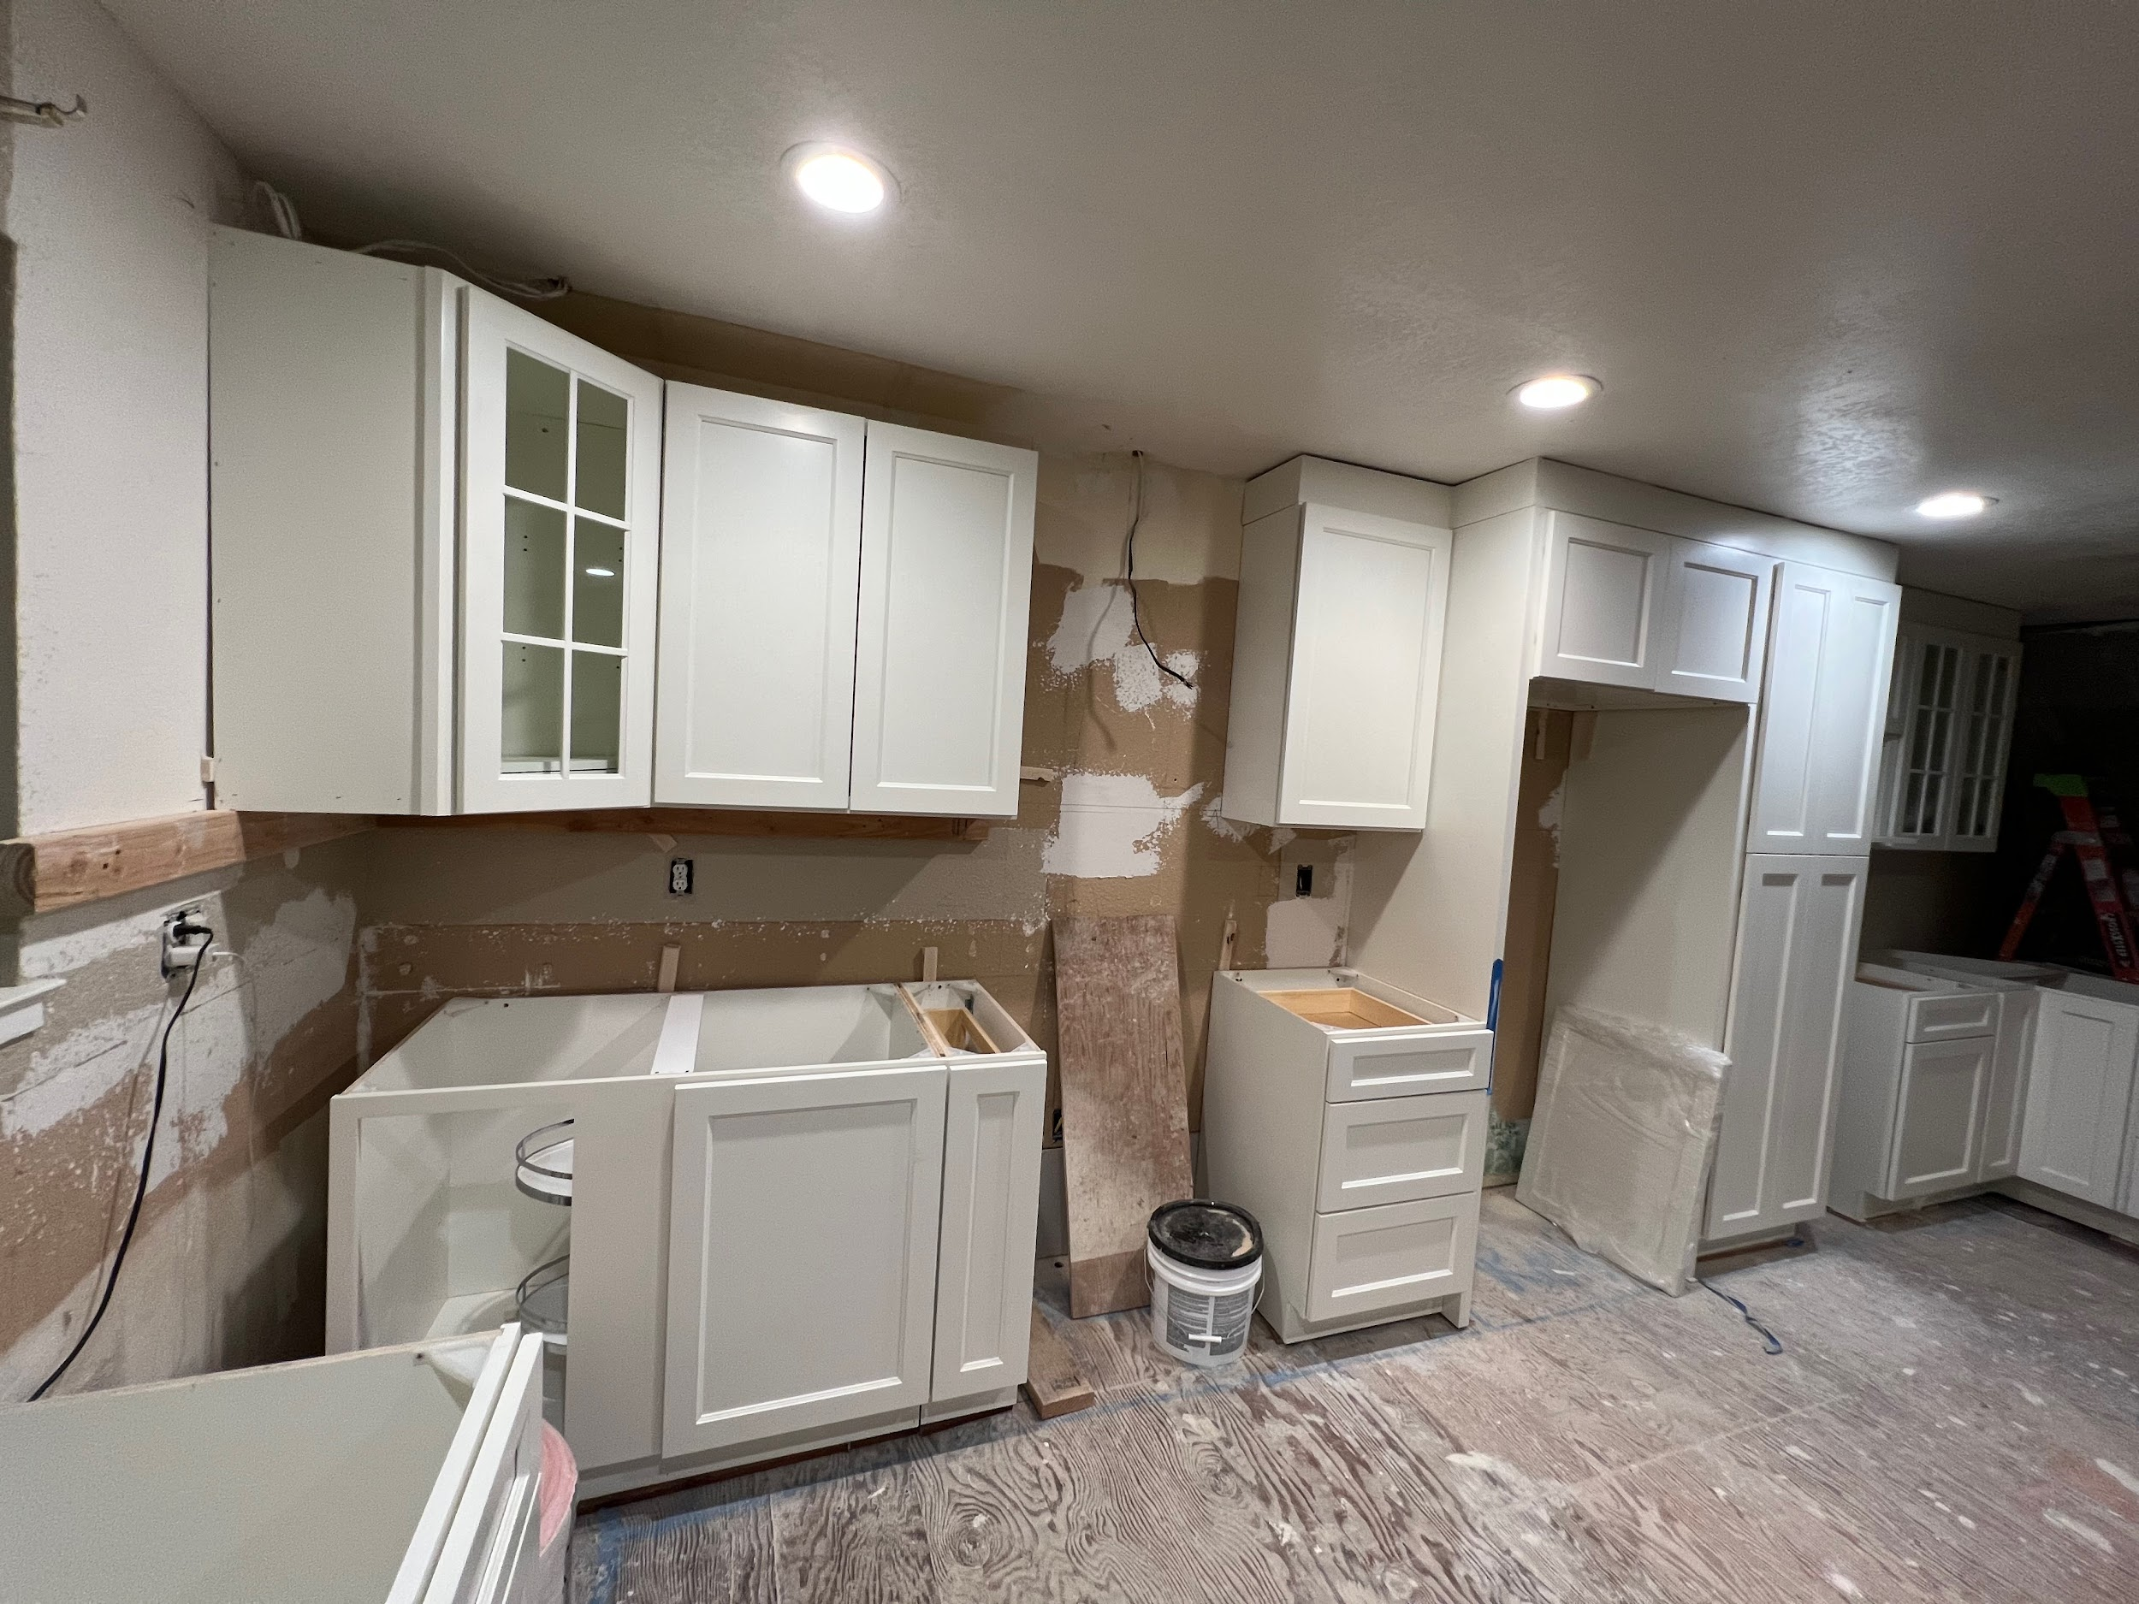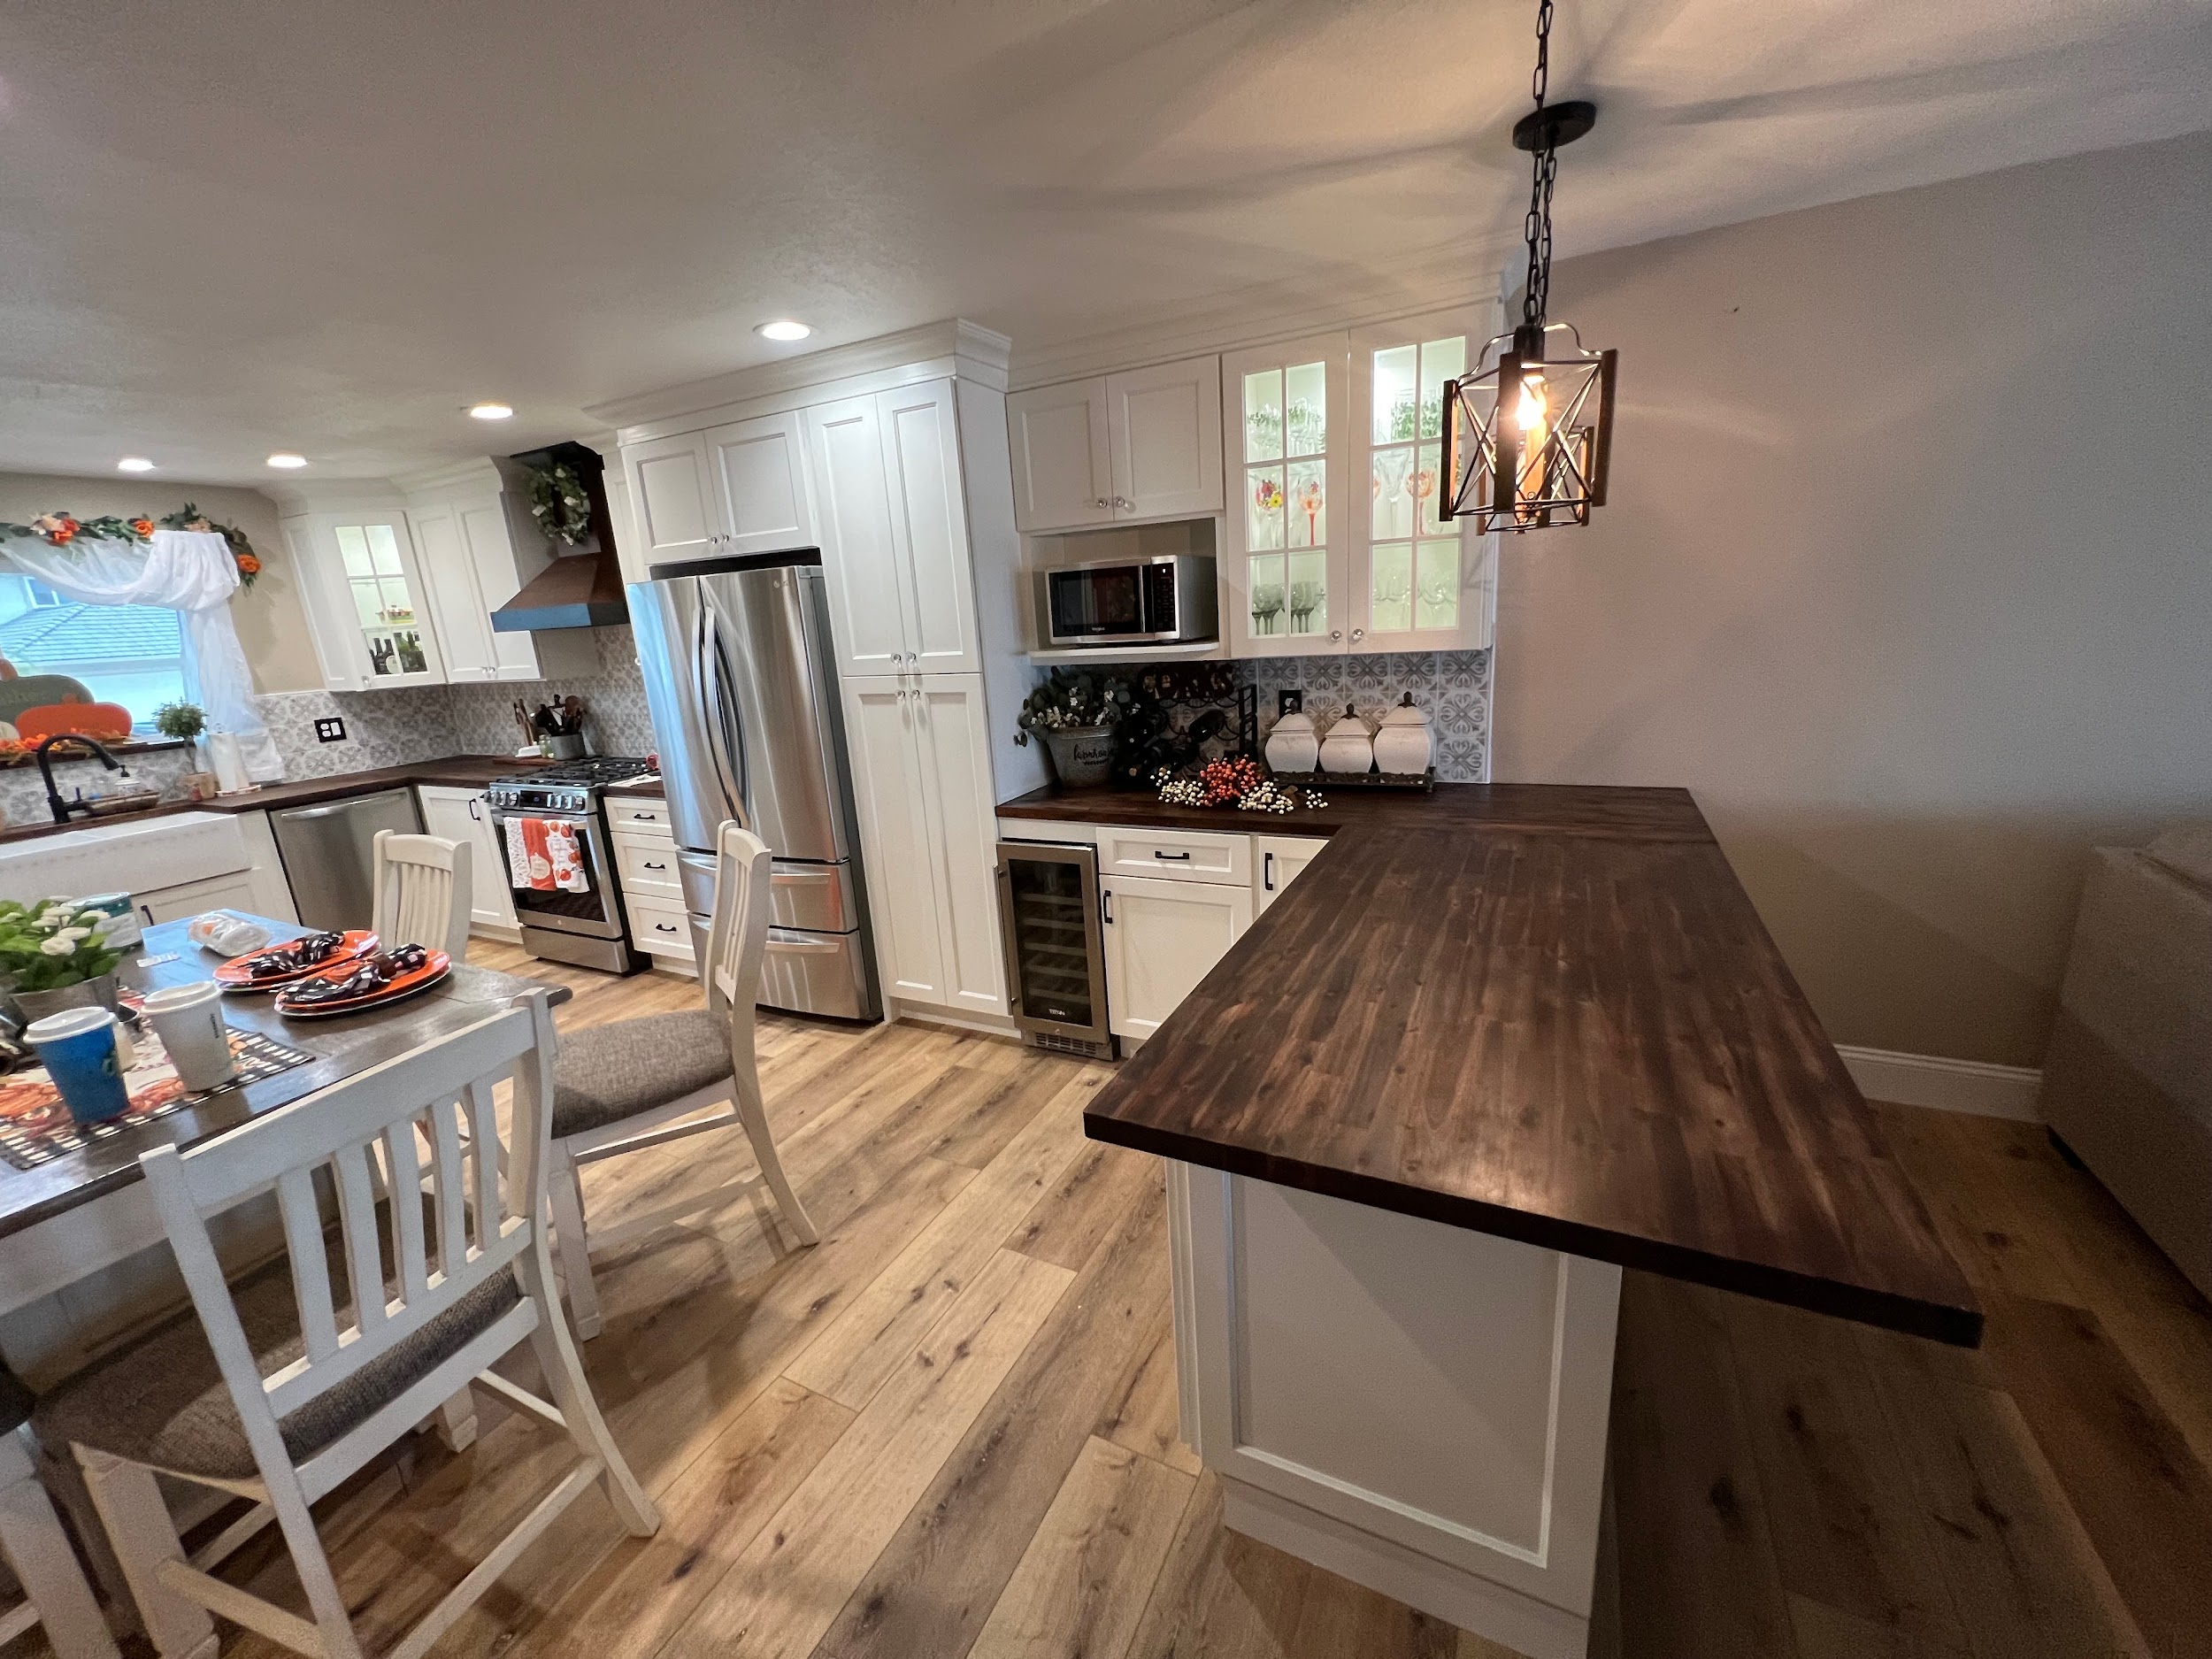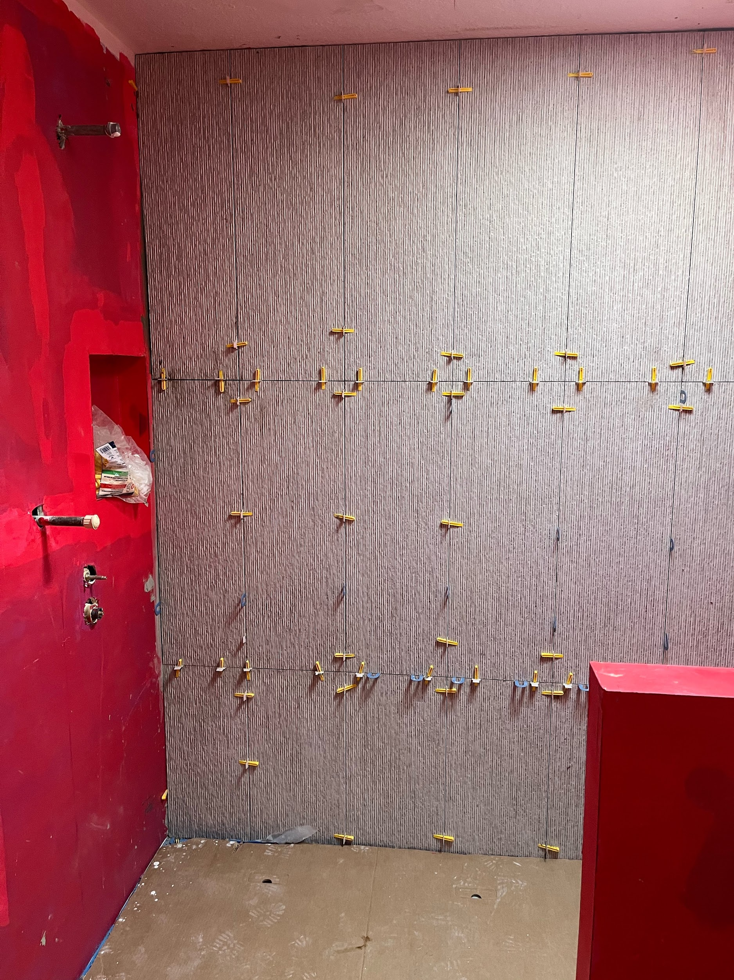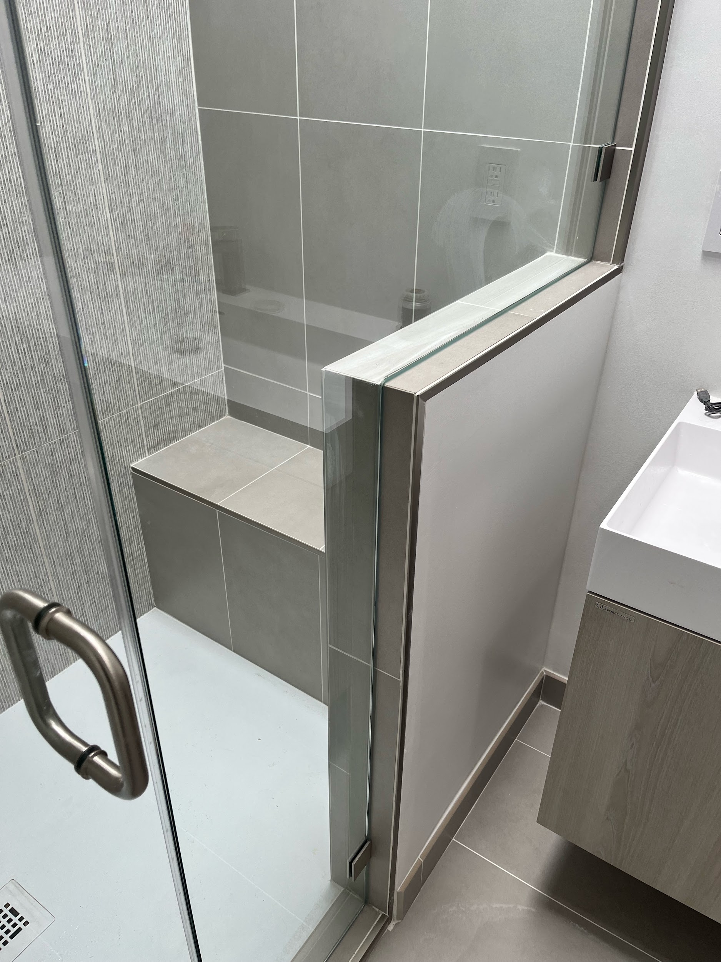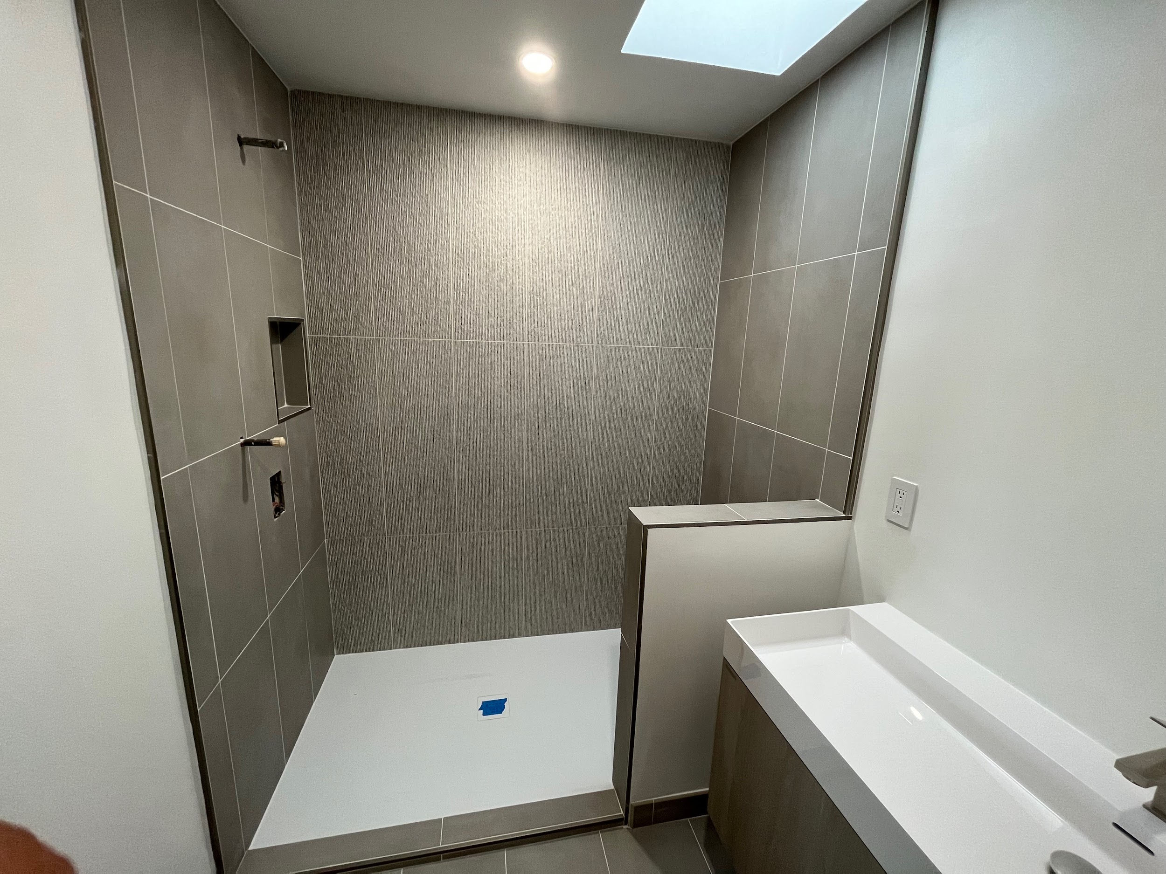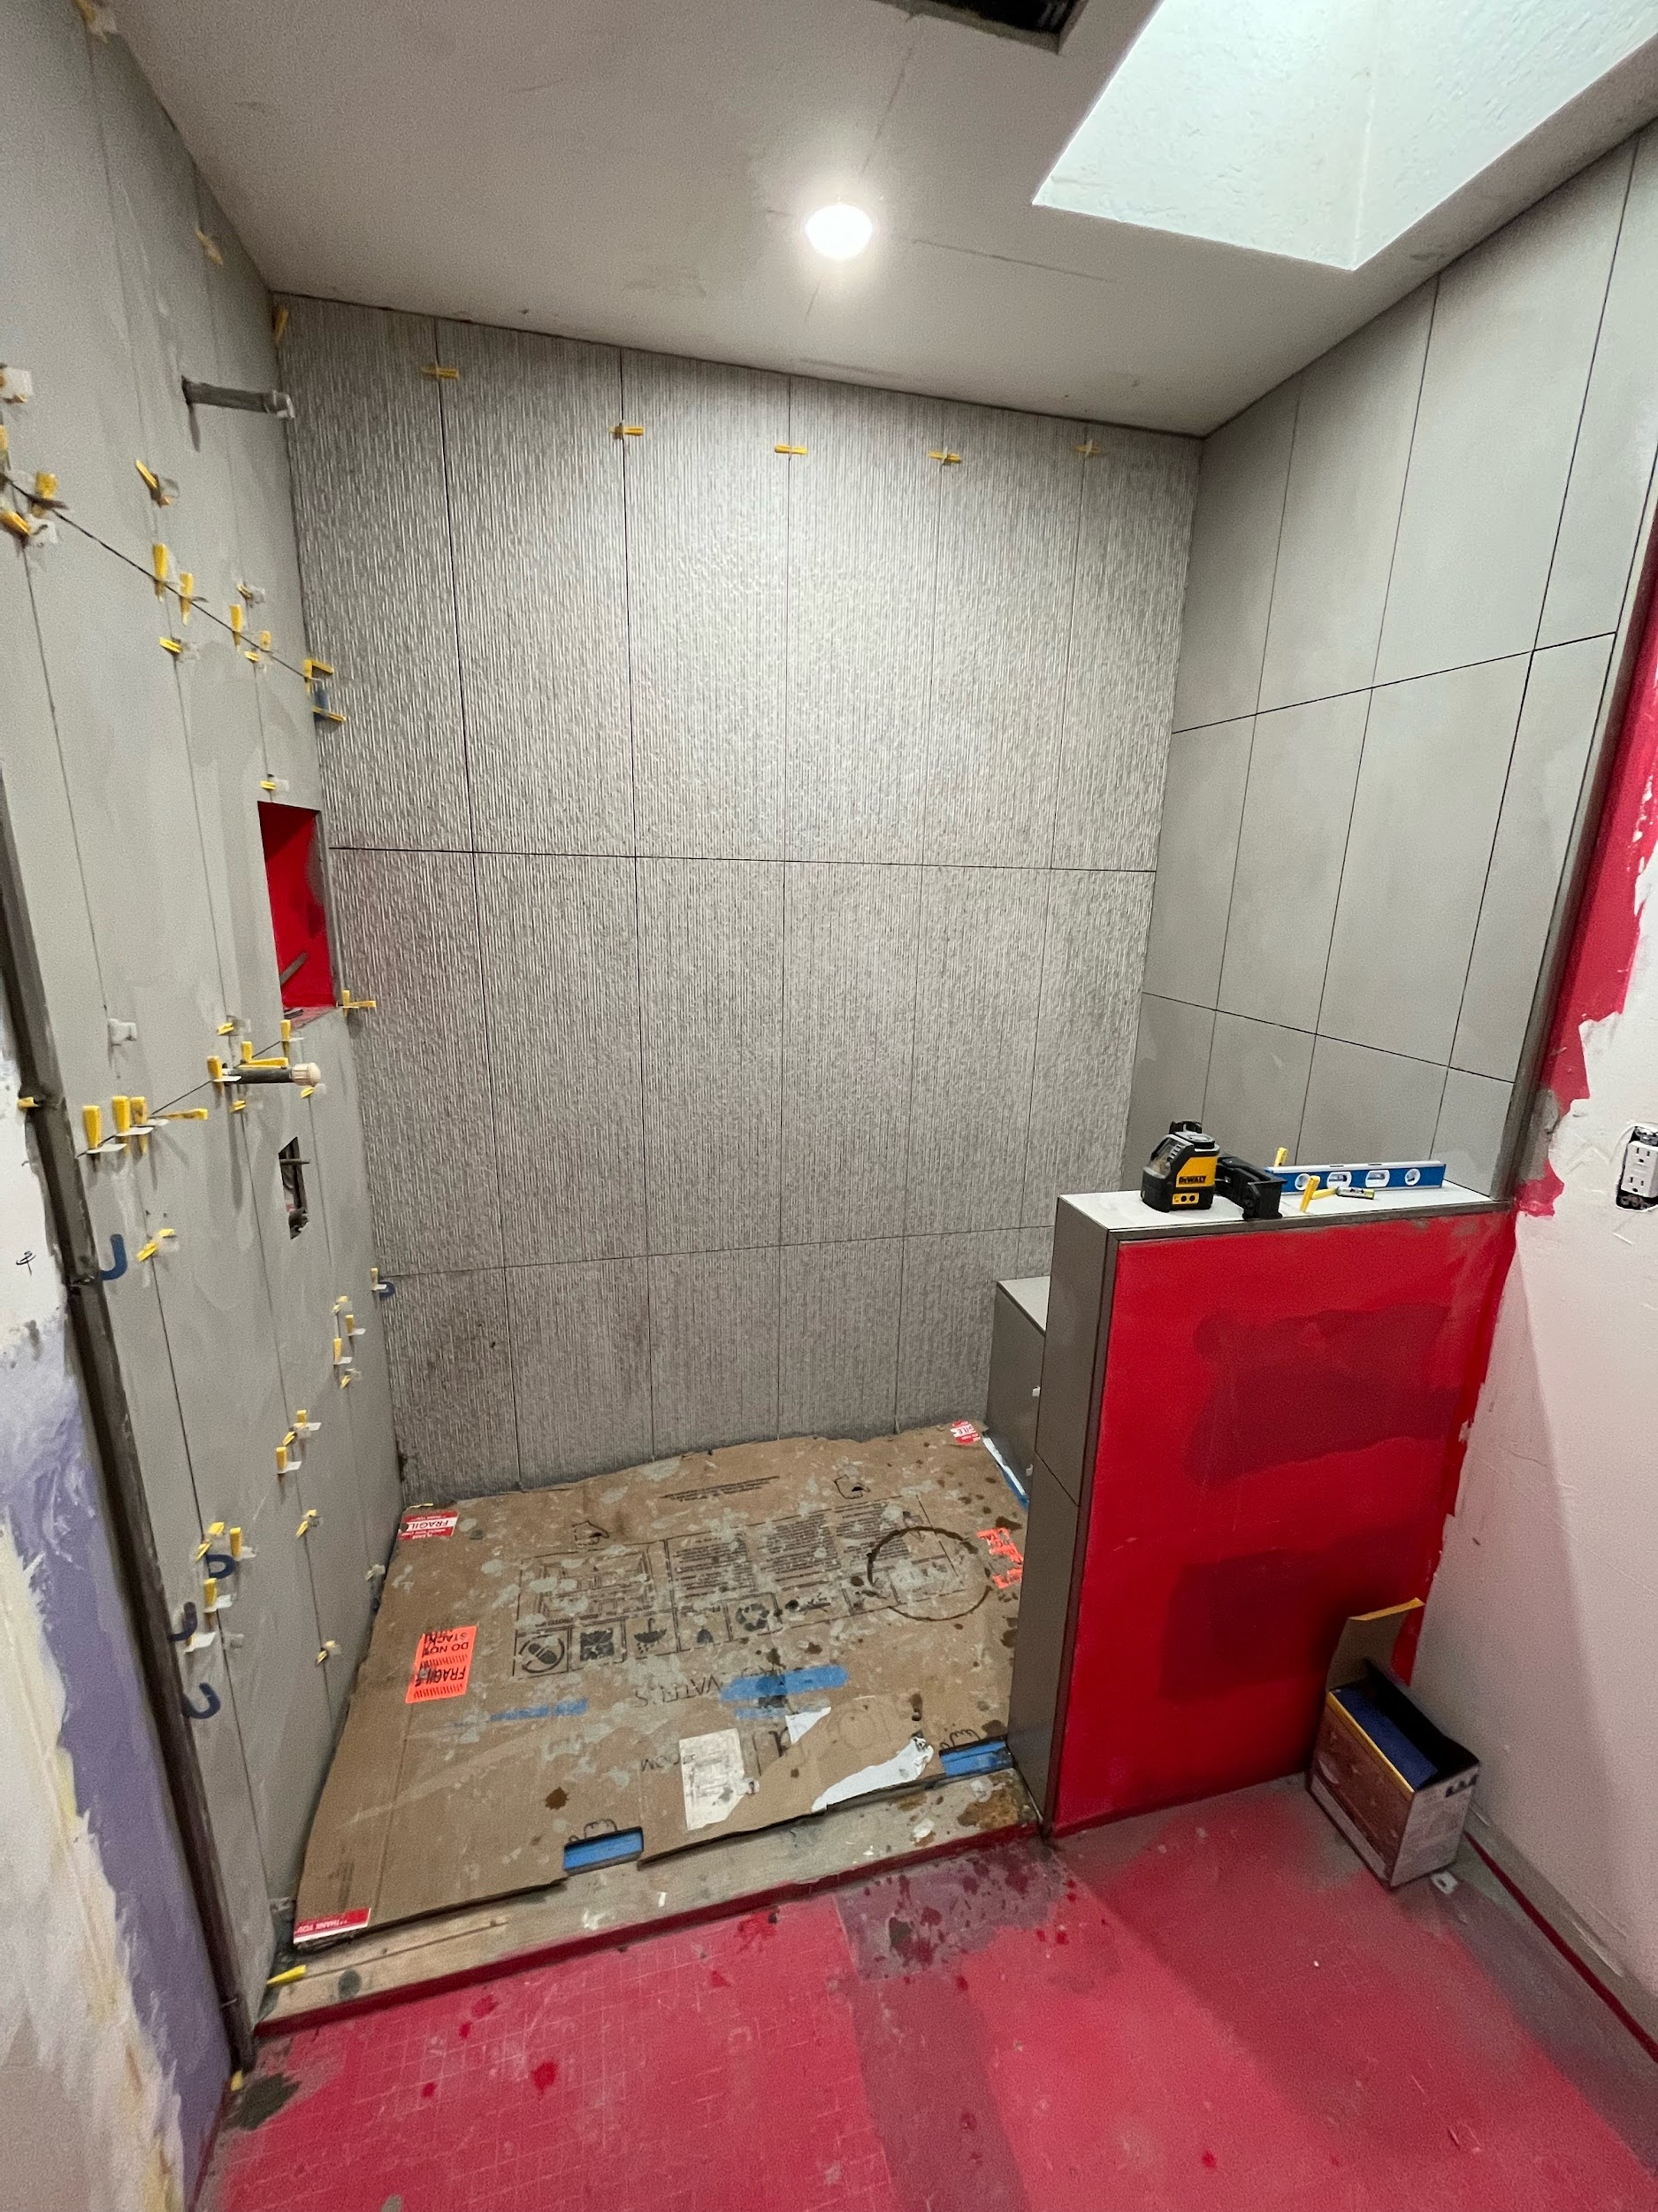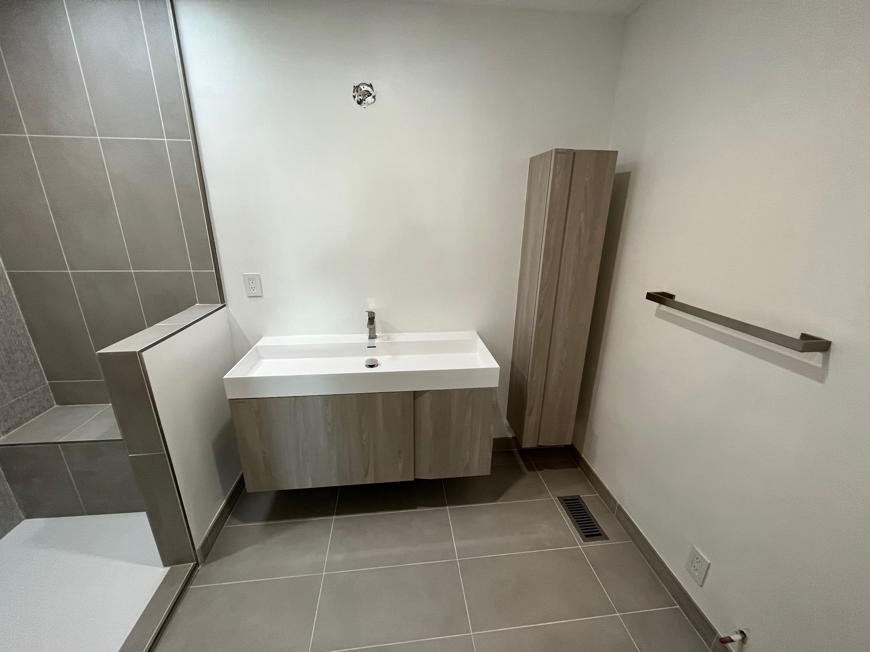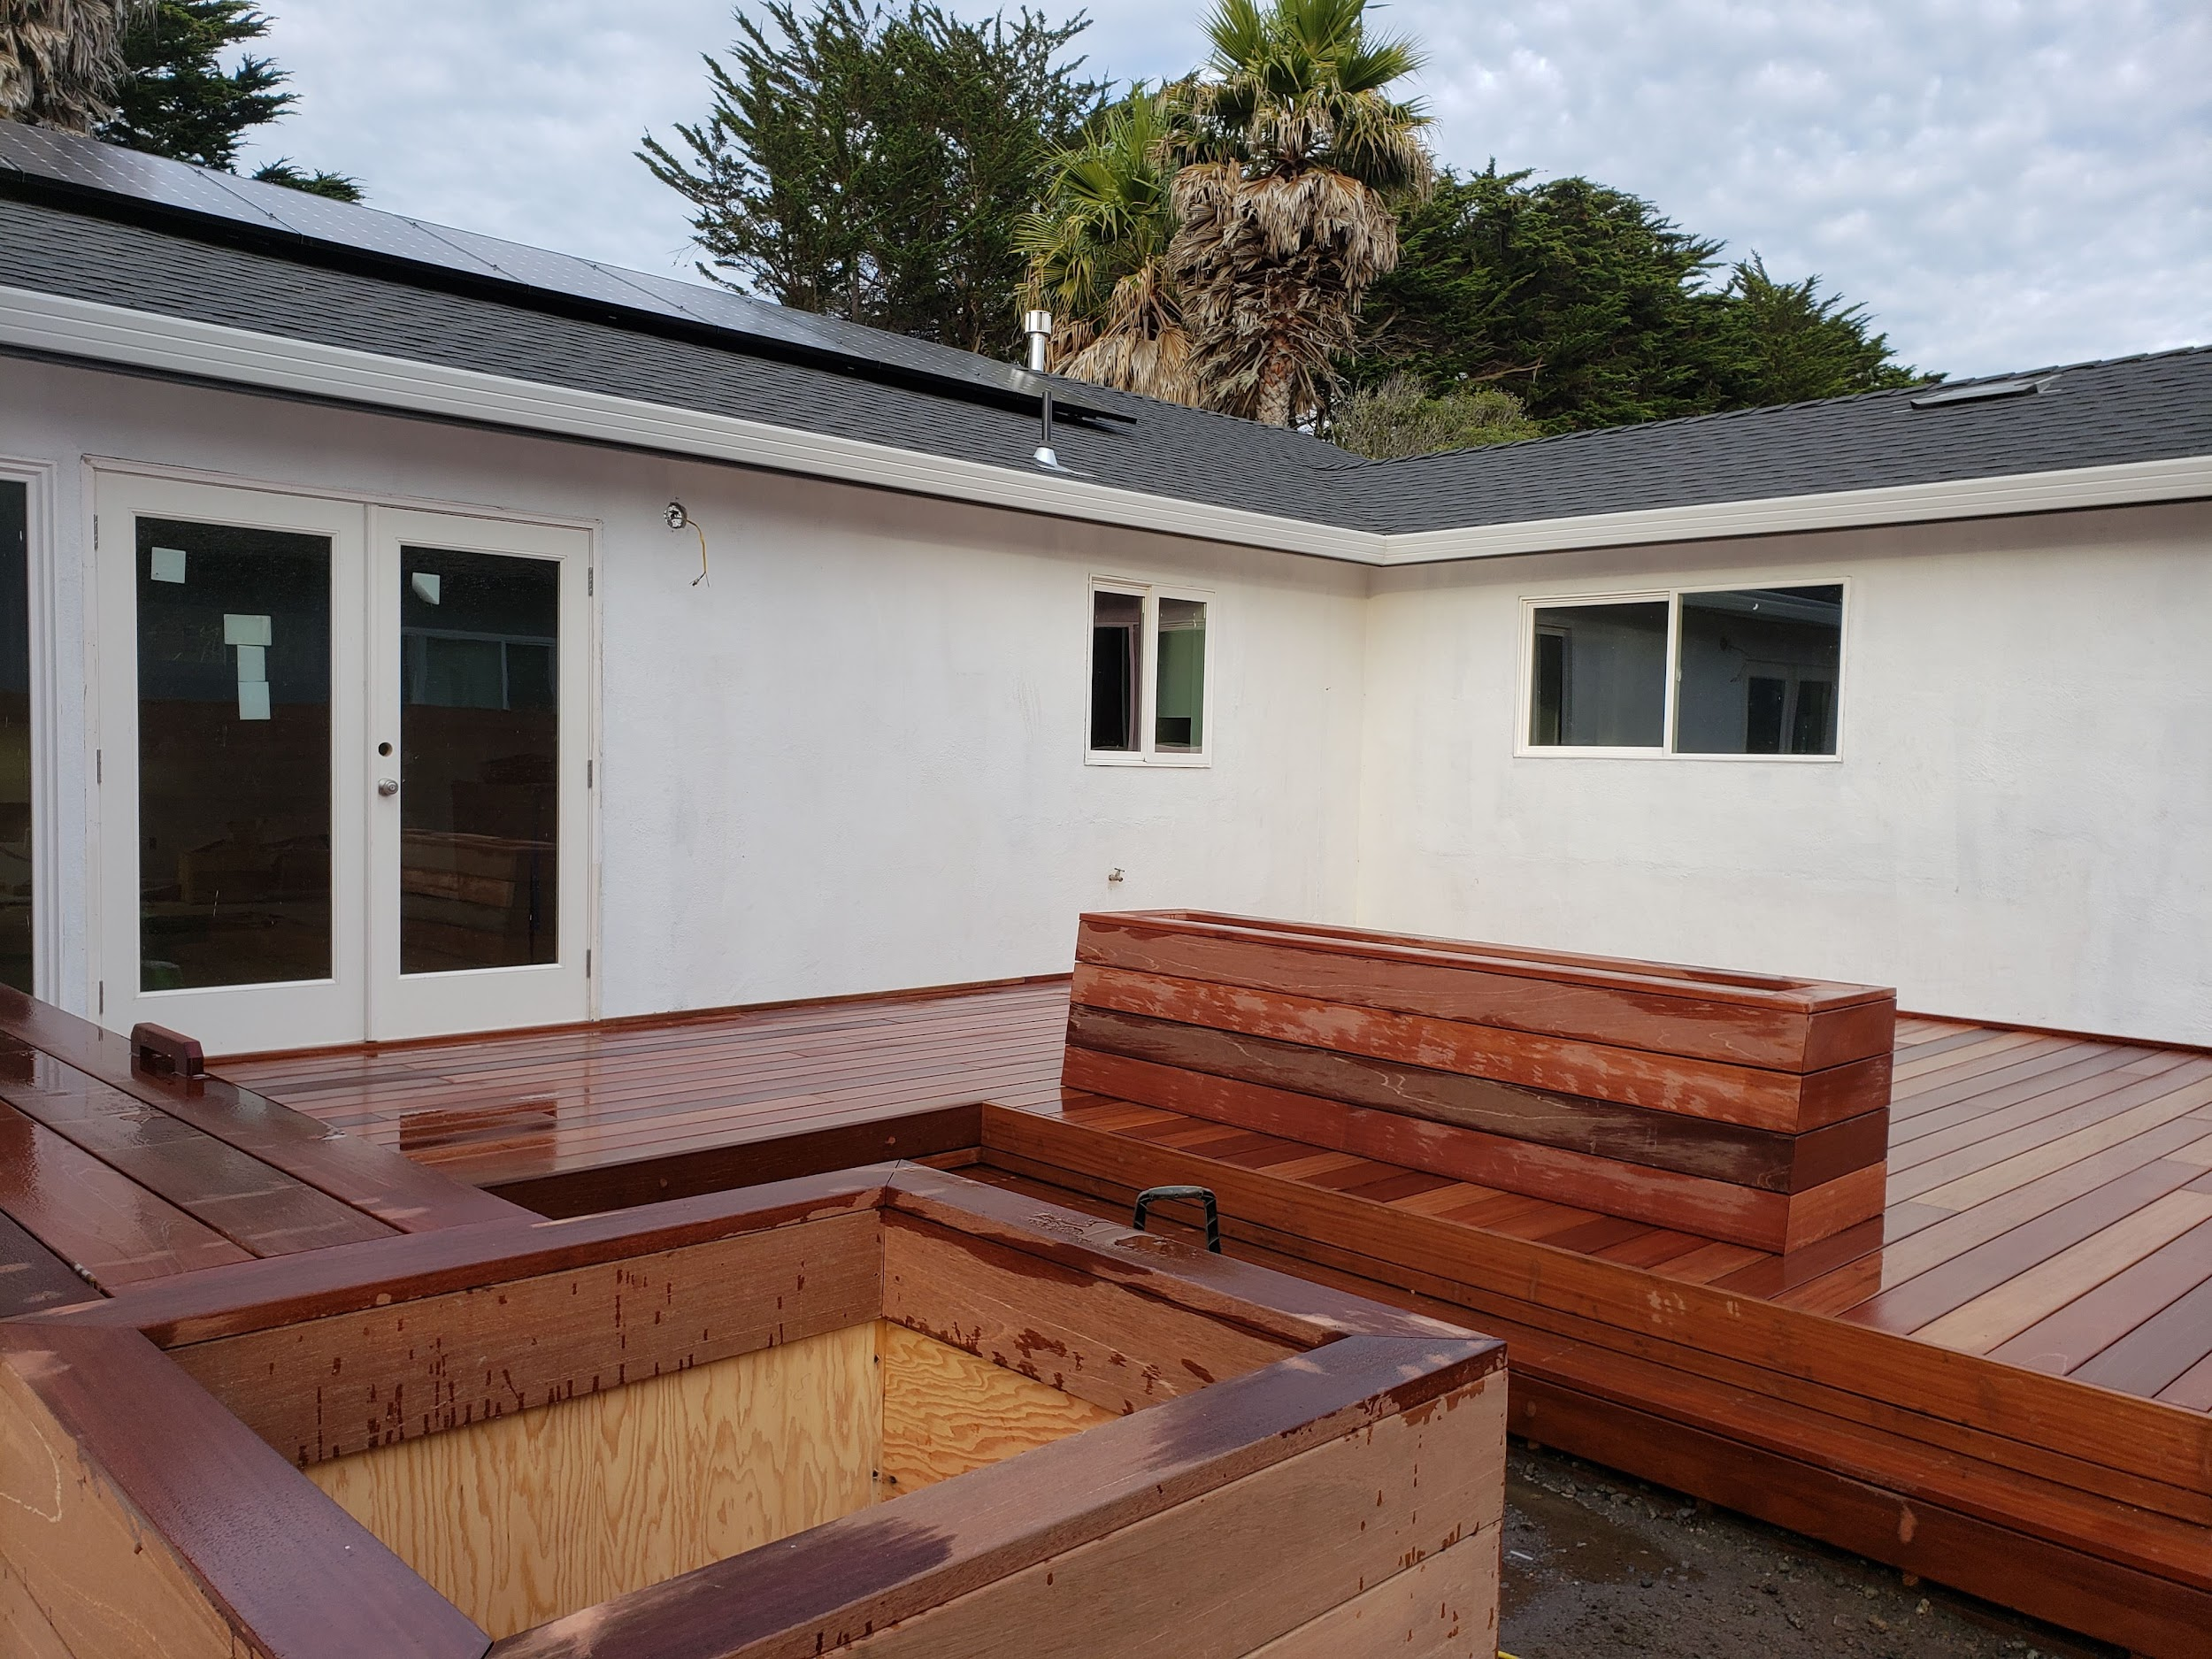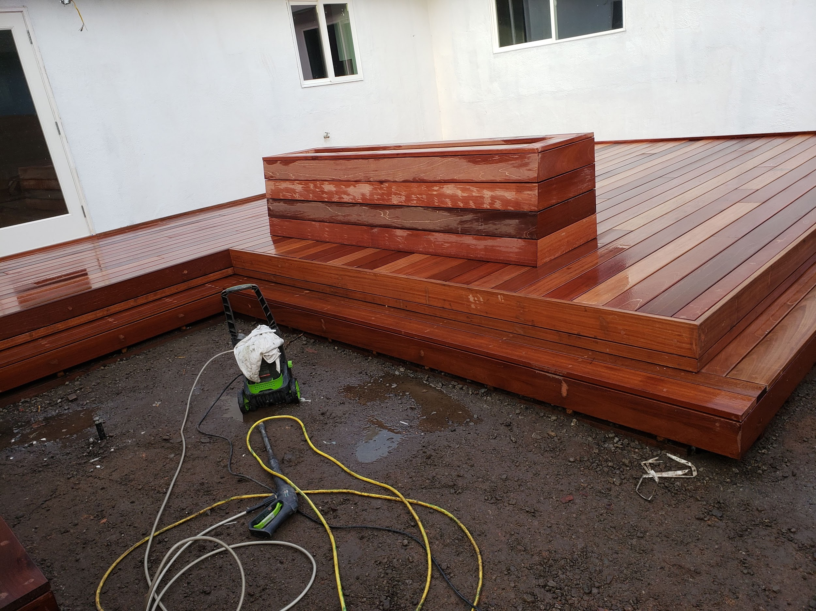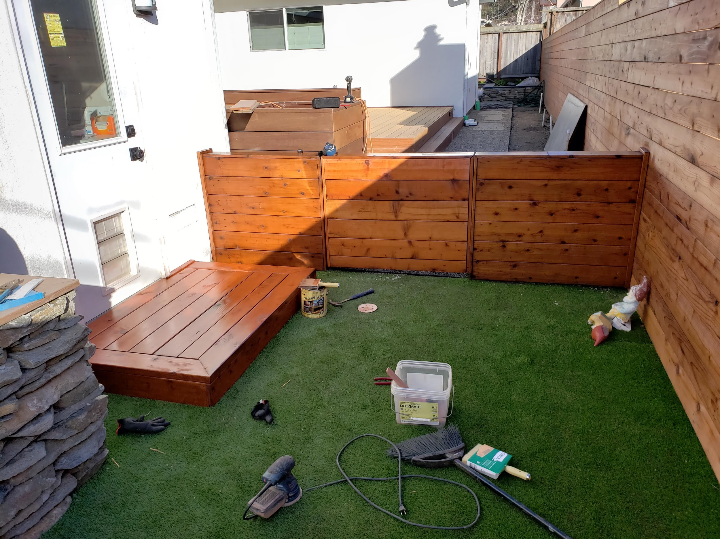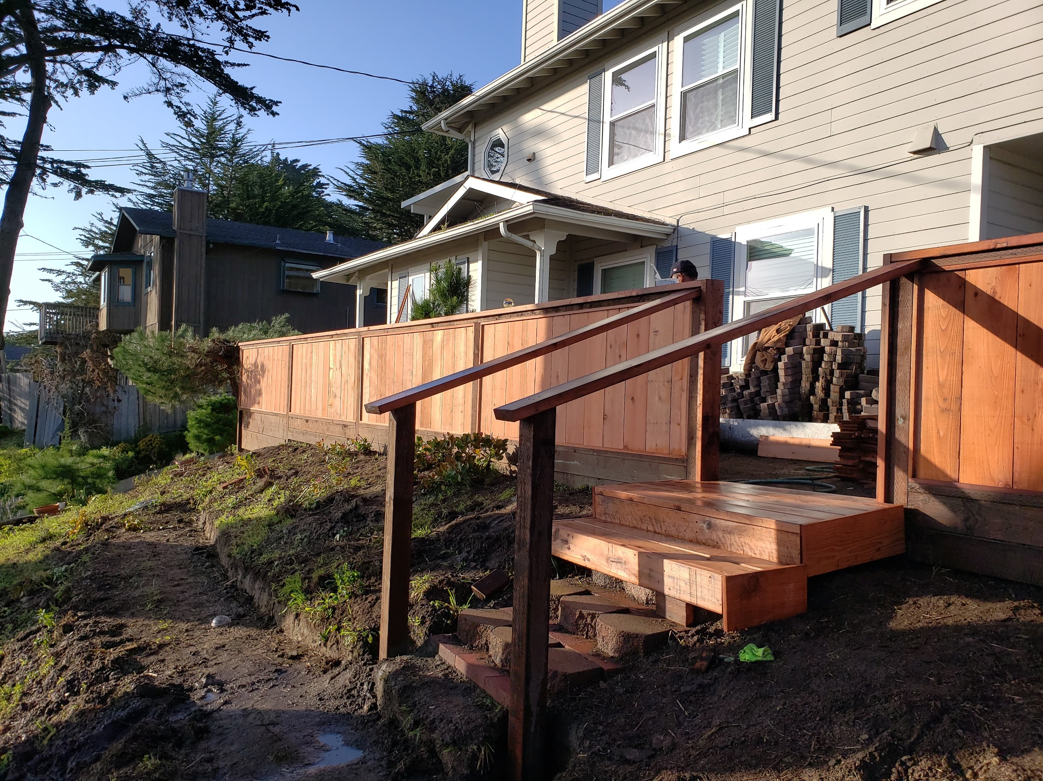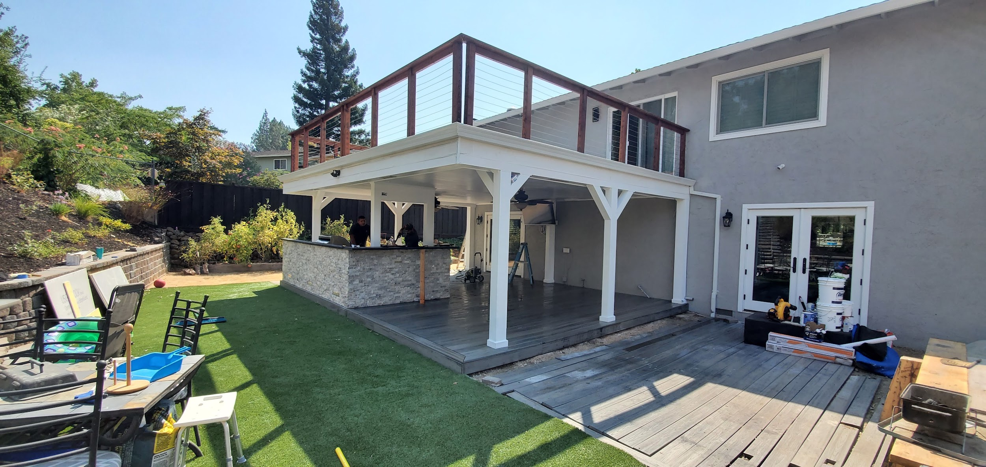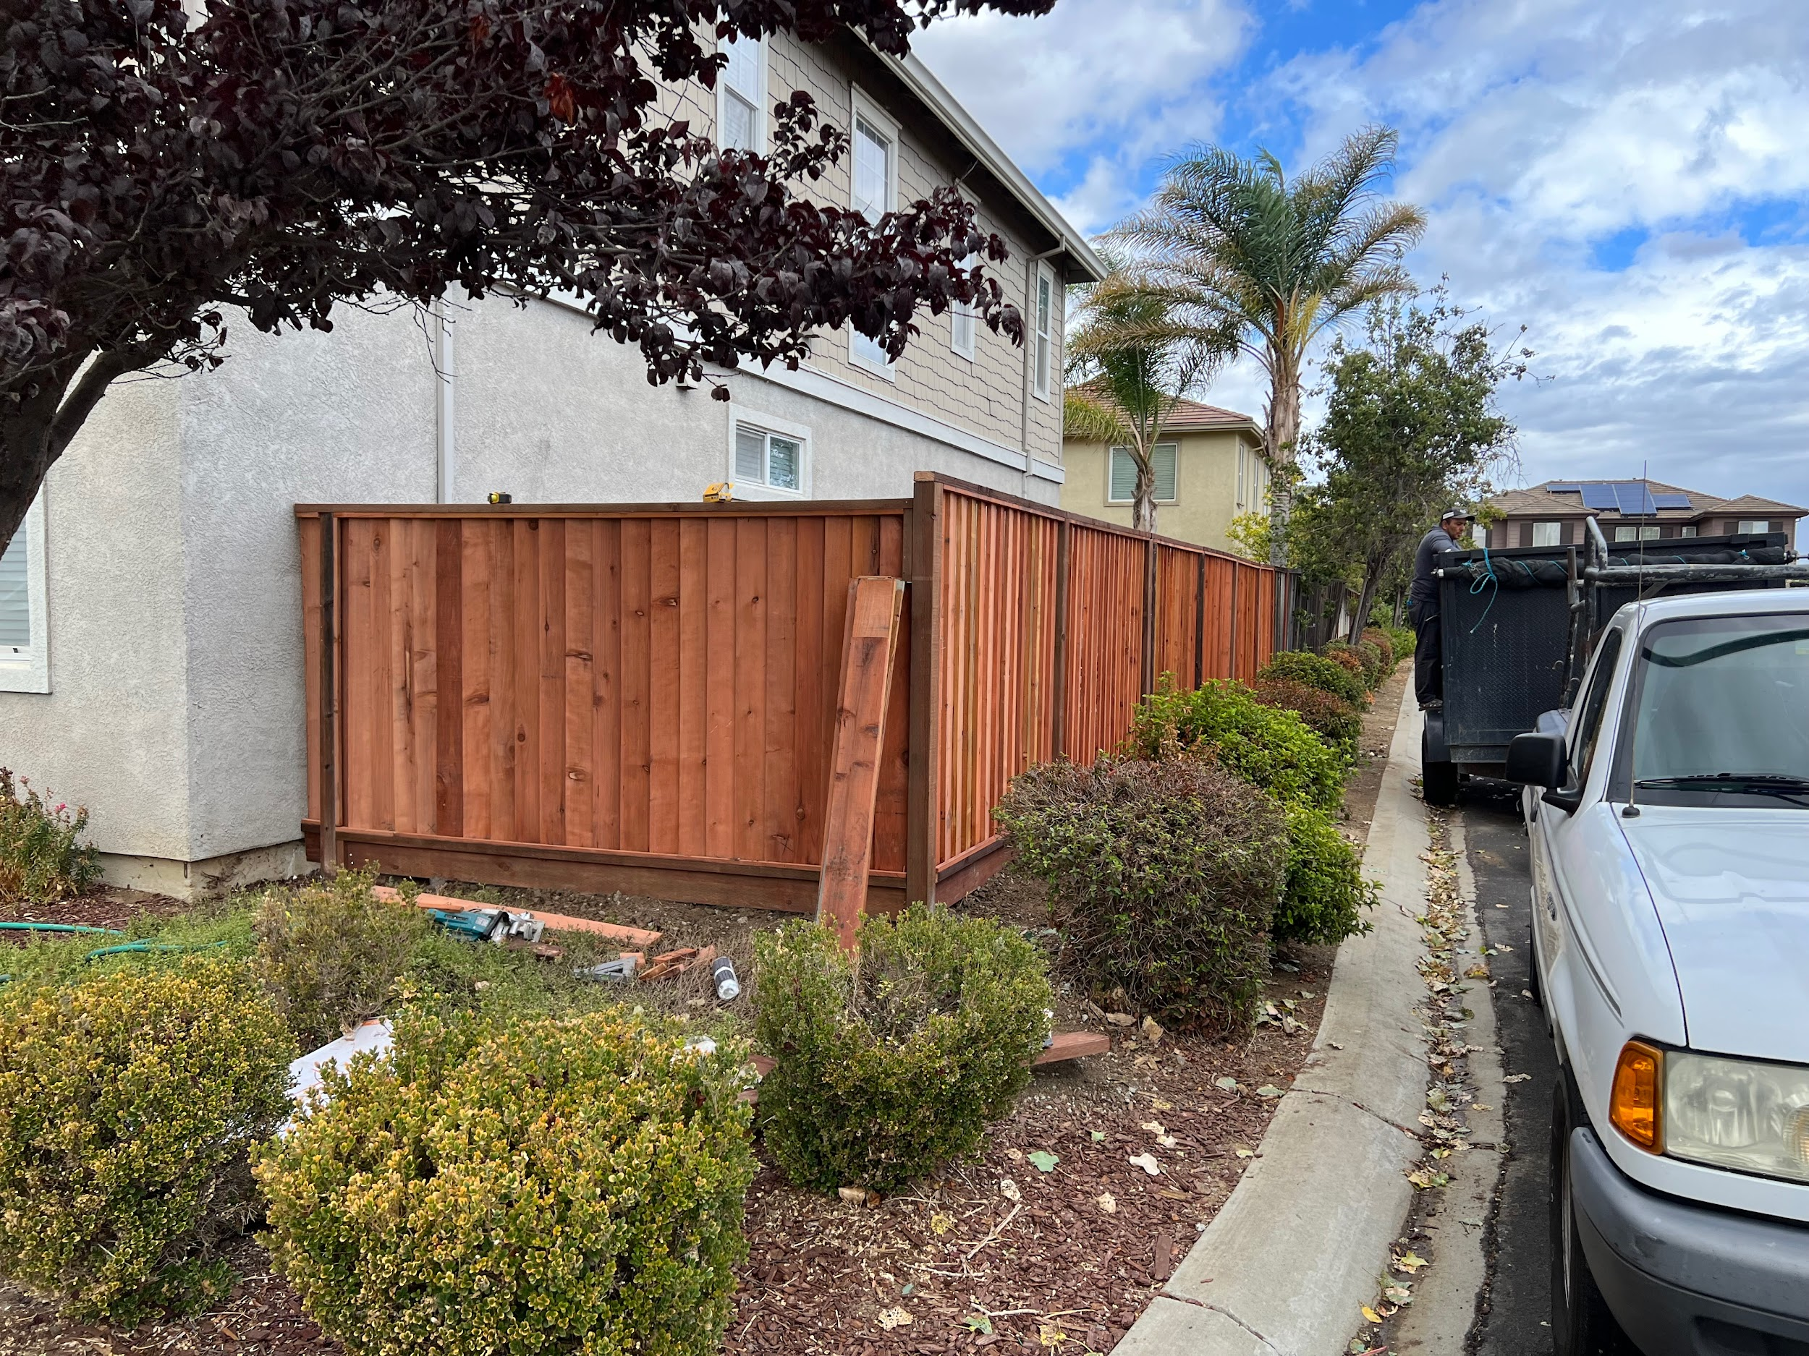

Jorge Chable

Thank you.